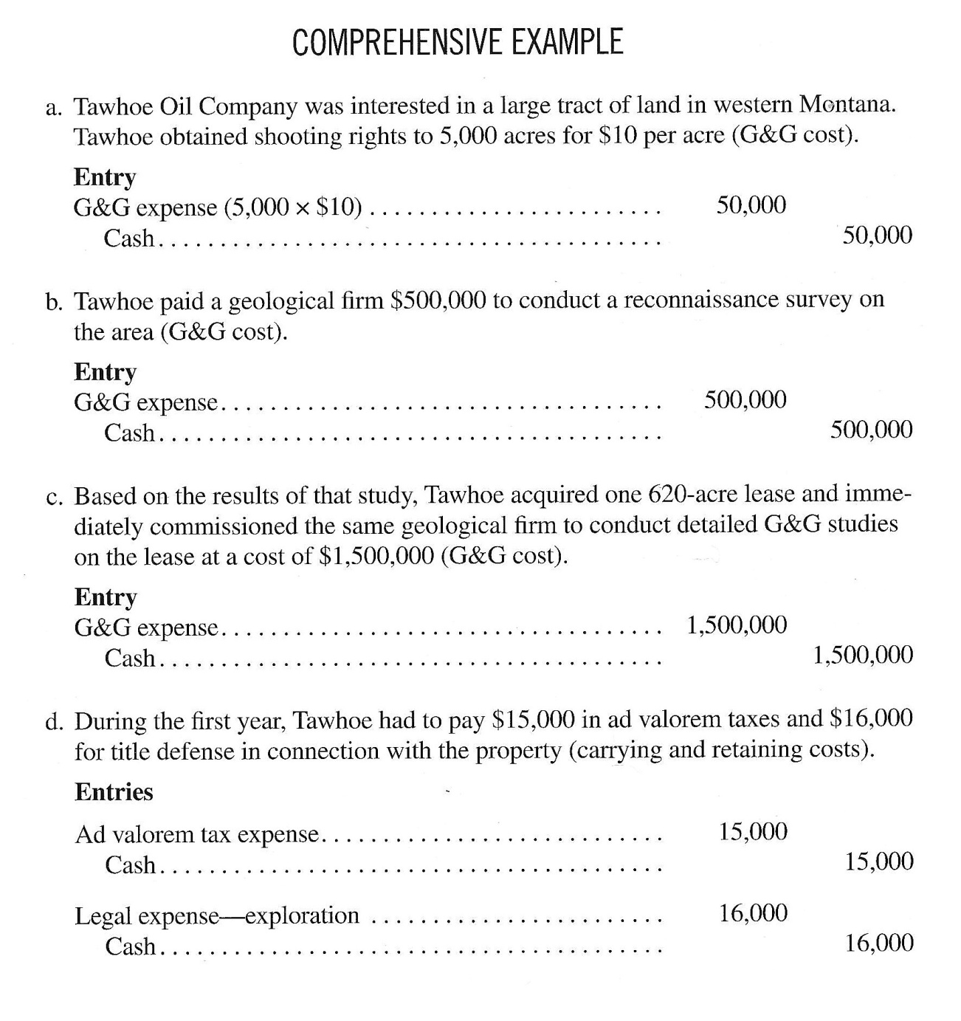 c. 1 **Entry**

Land Acquisition - Unproved………………………... 62,000

Cash………………………………………………….. 62,000

